Adobe install *Updated*

- Launch www.adobe.com
- Select sign in on the top right-hand corner
- Type in your uci email address
- Select option that says “Company or School account”
- Authenticate using the UCI authentication page
- Select the “my account Icon”
- Select view account
- Select Adobe for enterprise (Select view plan on the right-hand side.)
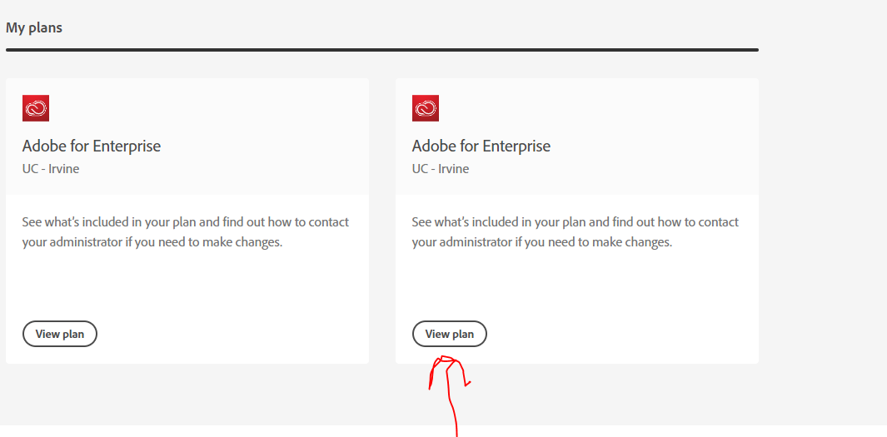

- Select download
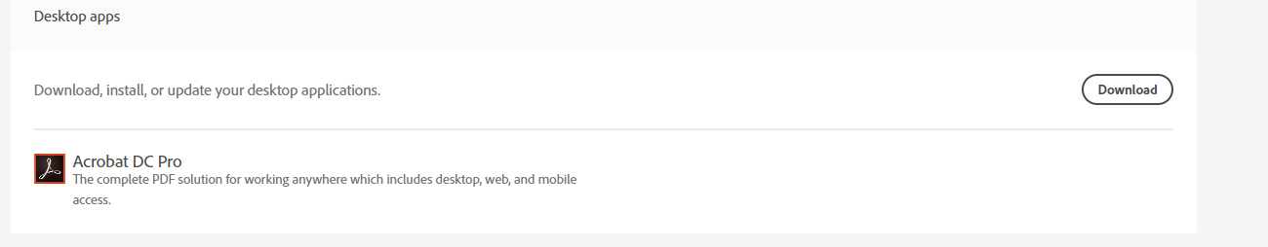
- Next launch the application from wherever it was downloaded, then install.

